**Controllers in K8s**

* Controllers are k8s objects which run other k8s resources. This k8s resource will be part of specification generally in template section.
* Controllers maintain desired state.
* Some of the controllers are
  + Replication Controller/Replica Set
  + Stateful Sets
  + Deployments
  + Jobs
  + Cron Jobs
  + Daemonset

**K8s Jobs**

* <https://kubernetes.io/docs/concepts/workloads/controllers/job/> for official docs
* K8s has two types of jobs
  + Job: Run an activity/script to completion
  + CronJob: Run an activity/script to completion at specific time period or intervals.
* <https://github.com/asquarezone/KubernetesZone/commit/7531d6e0c2a712f287ee41e5d53d94c6af3643ac> for the manifests with job and cronjob
* For jobs restartPolicy cannot be Always as job will never finish  
  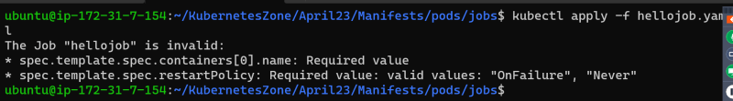
* Jobs have backoffLimit to limit number of restarts and activeDeadline seconds to limit timeperiod of execution.
* Running job and waiting for completion  
  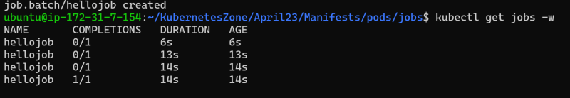  
  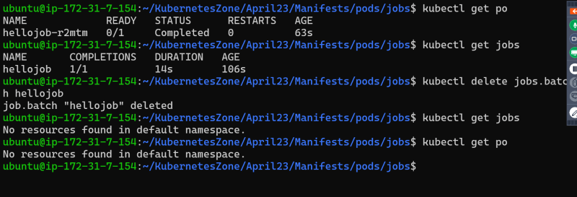
* Cronjob manifest which we have written create a job every minute and waits for completion  
  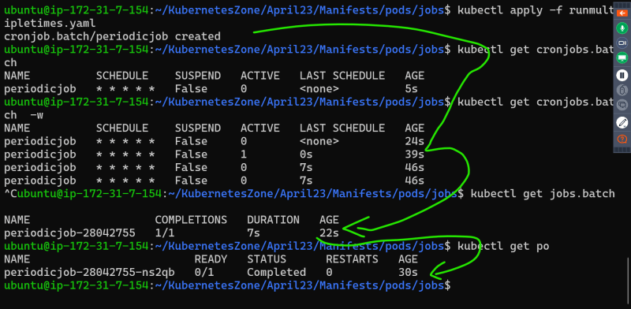  
  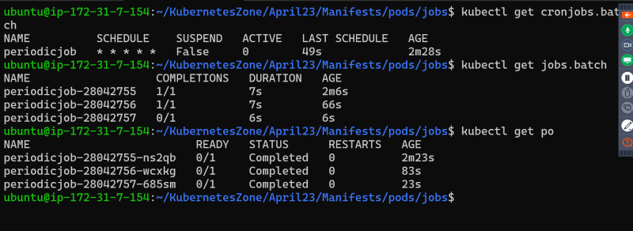  
  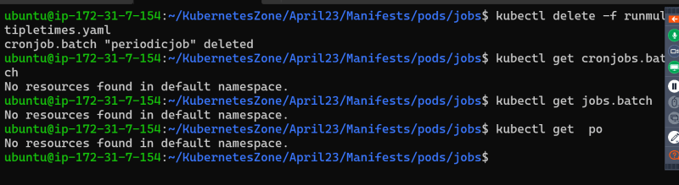

**Let’s go back to Pods**

* Lets run a alpine pod  
  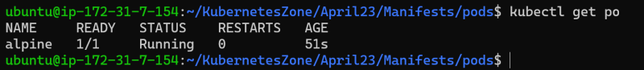
* Now if we want to execute a command in the container of alpine pod  
  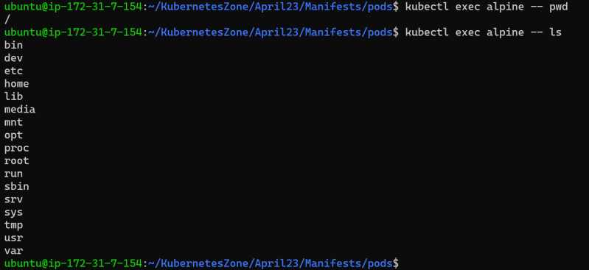
* To access the terminal  
  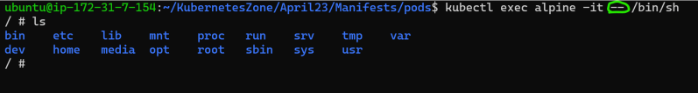
* Exercise: If we have a pod with 2 container how exec a command on a specific container
* Lets run a pod which run application on some port  
  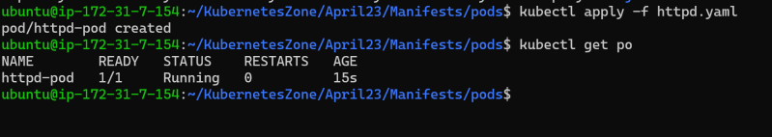
* Now if we want to access the application in container we can do port-forward (not recommended approach)  
  